**Meeting Minutes**

**Date:** March 4, 2014

**Start Time:** 3:30pm

**End Time:** 5:00pm

**Members Present:** Drew Aaron, Michael Beaver, Clay Boren,

Chad Farley, Andrew Hamilton, and Travis Hunt

**Members Absent:** N/A

**Topics** **Discussed**

* Architectural Design
* Detailed Design
* Division of Labor

**Decisions and Actions Taken**

The team discussed how to organize the components of the Architectural Design to facilitate the Detailed Design process. The Frontend has been divided into five groups, which will receive detailed designs at a later date: the Main Form; the View .PRT Dialog Window; the Output Dialog Window; the Options Dialog Window; and, the About Dialog Window. The Backend has been divided into four groups, which will receive detailed designs at a later date: the Drivers; the Data; the Memory; and, the Functionality. See the attached graphics.

Each Frontend group has components and, if necessary, dialogs. The Main Form is composed of the following components: the Source Code Editor; the Registers Display; the Memory Display; the Symbol Table Display; the Toolbar; and, the Menubar. The Main Form is also composed of the following dialogs: the Open Dialog; the Save Dialog; the Print Dialog; the Import Dialog; and, the Export Dialog. The View .PRT Dialog Window is composed of the following components: the .PRT viewer; a Print button; and, a Close button. The View .PRT Dialog Window also makes use of the Print Dialog. The Output Dialog Window is composed of the following components: the Output field; and, a Close button. The Options Dialog Window has the following components: a checkbox for determining whether to save a .PRT by default; the maximum number of source lines; the maximum number of instructions; the maximum number of printout pages; the maximum size in bytes; possibly ASSIST/UNA-specific options; and, an Apply button. The About Dialog Window will have informational text and an Ok button. The Output Dialog Window, the Options Dialog Window, and the About Dialog Window do not use any external dialogs.

Each Backend group has components but no dialogs. The Drivers group consists of the Assembler and Simulator. The Data group consists of the Symbol Table, the Memory, and the .PRT file. The Memory is further subdivided into Memory Contents and Registers for the Simulator. Finally, the Functionality consists of Error Detection, an instruction Library, and an instruction Translator.

The team also briefly discussed the division of labor. Work has been divided into work on the Frontend and the Backend. Drew has been appointed Frontend Lead and Integration coordinator. Clay will be assisting with Frontend Design and Testing. Andrew will also be coordinating and conducting Frontend Testing. The Frontend team will be (re)incorporated into the Backend team as needed or whenever work on the Frontend has concluded. Chad has been appointed Backend Lead. Michael, Travis, and Andrew will be assisting with Backend Development. Andrew will also be leading the Backend Testing efforts. Drew and Chad have the authority to delegate tasks as well as to work with subgroups on complex tasks. Precise divisions of the team will be determined as the full implications of the design become realized. See the attached graphic.

The team will begin work on the Detailed Design and further refine the division of labor at the next team meeting. The next team meeting will be Thursday, March 6, 2014 at 3:30pm in the Keller Lab.

**Supplementary Information**

**Frontend Groupings**

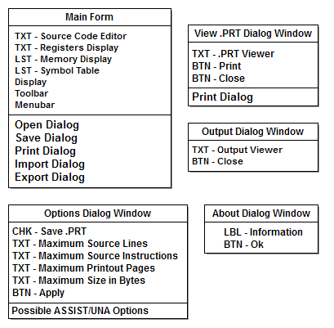

**Backend Groupings**

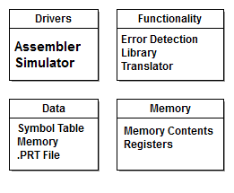

**Division of Labor / Team Organization**

